CAMPUS MAP

University Center Tower (UCT) - Pre-Proposal Conference in Room # 1236
7000 Fannin Street (parking garage available)
Houston, TX 77030

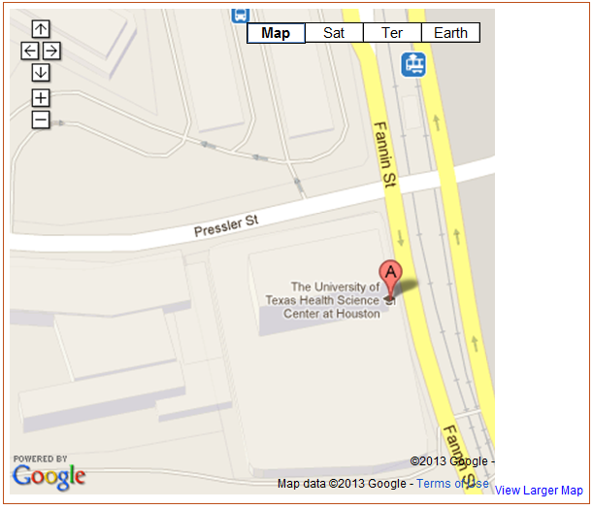
UCT &
Pay Parking Garage

