Appendix 4

CAMPUS MAP

University Center Tower (UCT)
7000 Fannin Street (parking garage available)
Houston, TX 77030

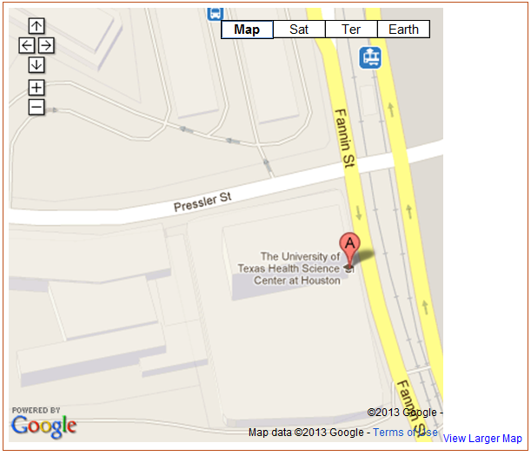
UCT &
Pay Parking Garage

Medical School Building (MSB)
6431 Fannin Street (parking garage available at UPG across street)
Houston, TX 77030
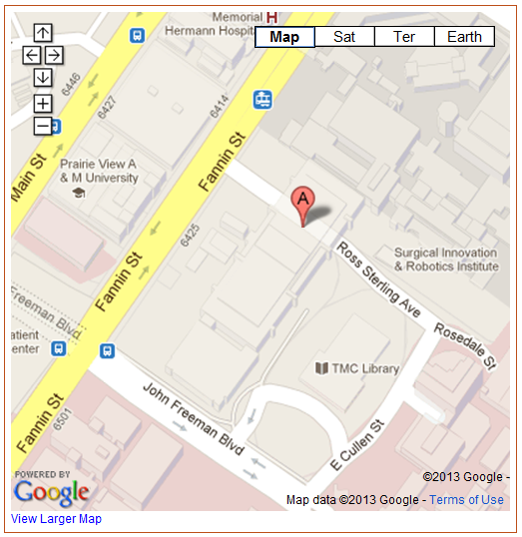
Pay Parking Garage
MSE
MSB

School of Public Health (SPH / RAS)
1200 Pressler Street (underground parking garage available at MDA across street)
Houston, TX 77030

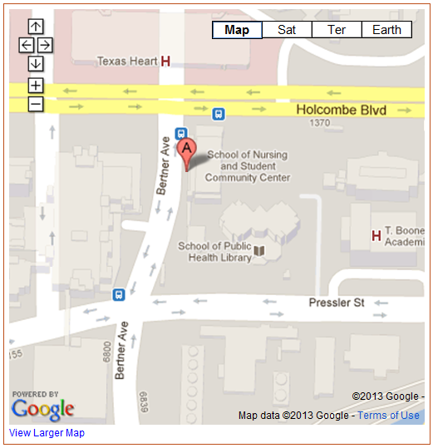
SPH
Pay Parking Garage
Pay Parking Garage
Pay Parking Garage

Visitor Parking Lot
REC

