Slide 1
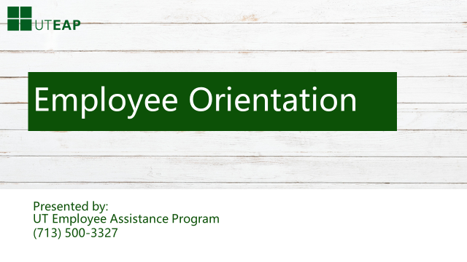
- Hello and welcome to the UTEAP Orientation
- On behalf of our staff, I would like to take this opportunity to welcome you to your Employee Assistance Program AND Thank You for your trust in our service.
- The University of Texas Employee Assistance Program is affiliated with UTHealth, an academic Health Science Center in Houston. We provide EAP services to mainly local and regional organizations.
- We serve a wide range of both public and private companies ranging from small employers to large organizations.

- Our Affiliation with UTHealth allows us to offer evidence-based clinical service as well as taking advantage of the latest in technology including Web based service delivery.
- UTEAP provides one of the most comprehensive Employee Assistance Programs available. We credential only the most qualified and experienced mental health providers. And our staff are second to none in knowledge, commitment and responsiveness to those seeking services. They are also empathetic and are genuinely concerned about wanting to help employees and their families.
- Our Web site is easy to navigate and offers practical and time saving resources for education, training and a wide range of work life services.
- Our Philosophy is straightforward and quite simple: We will always work hard to exceed your expectations for customer service.
- This goal is not something we take lightly. In fact, meeting your expectation for service delivery is a promise that we make to you.
- We are keenly aware that our success will be measured through your eyes and not ours. Should we ever fail to meet your expectation for services, you simply need to re-contact us and we will do all in our power to correct the situation.
- That’s a promise we make to you.

Slide 2
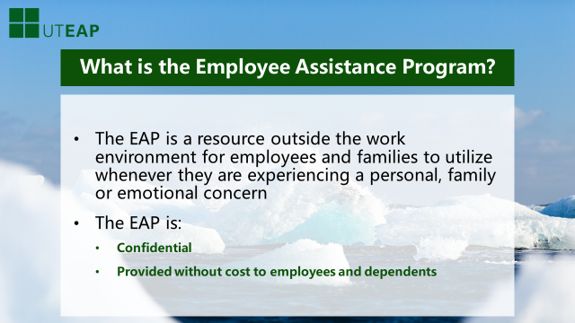

Let’s start the training today with a simple question—What is an EAP?
An employee Assistance Program is a resource outside the work environment that is available for employees and your family members to utilize whenever they are experiencing a personal, family, emotional or a wide range of other problems and concerns.

The EAP is CONFIDENTIAL
AND it is PROVIDED WITHOUT COST TO YOU AND YOUR FAMILY.

Slide 3

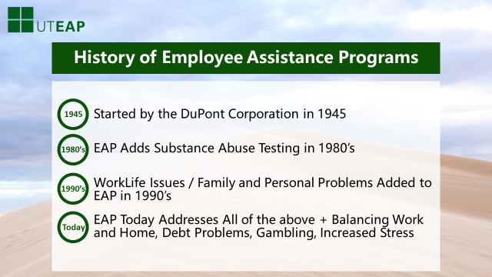
- Employee Assistance Programs actually started in the mid 1940’s when the DuPont Corporation introduced a program to assist employees who were having problems with alcohol. Although this program was successful the concept of EAP’s really did not catch on until the early and mid 1980’s.
- In the 1980’s, Substance Abuse was again becoming a concern to business and industry. Approximately 30% of the workforce was using illegal drugs, mainly marijuana. Accident rates, absenteeism and production problems were becoming of concern and for the first time, companies began drug testing. EAPs were re-introduced into the workplace as a resource for people to use in solving their drug use problems prior to failing a drug screen.
- Unfortunately, this focus on Substance Abuse problems led most people to believe that EAP’s were only for help with alcohol and drugs.
- That perception changed quickly in the late 1980’s when employers started to see a significant increase in marital, family and emotional problems. EAP programs recognized that many times marital, family, legal and financial problems could be addressed as a precursor to alcohol and drug issues. And Again, EAP’s were used by employers to help employee families in solving these new problems.
- Today, EAP’s are focusing on new areas of concerns. EAP’s are now being asked to help employee families in balancing their work and home. Emotional concerns continue to increase and problems such as Depression, Gambling, and increased financial problems are frequent. Today families struggle to have enough hours in the day to accomplish what they need to do. Balancing Work and Home has become a challenge for many of us.
- In addition, EAP’s also help employees develop tools to resolve workplace conflicts, professionalism as well as other behaviors impacting the workplace. It is our mission to prevent burn-out and improve resiliency.

Slide 4
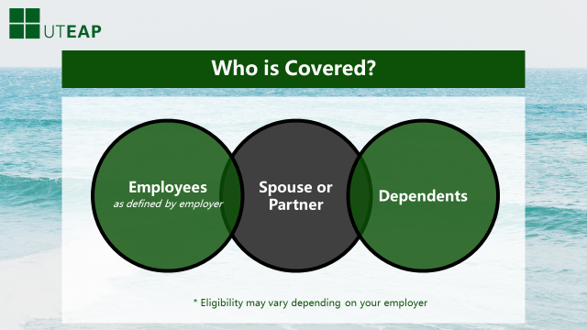
UTEAP services are provided without cost to all employees and their immediate family members.
Eligibility may vary depending on your employer.

Slide 5
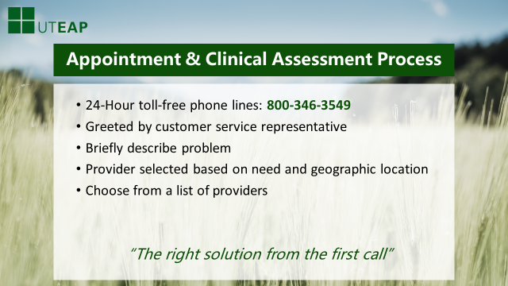
The process of getting EAP services is simple
- All you need to do is call the number for your organization and you will immediately be talking with one of our Customer Service Representatives.
- The Customer Service Representative will ask you where you work and to briefly describe your problem. They will ask you where you would like to be seen — near your office or near your home.
- A list of counselors will be sent to you. You will then select a counselor who is skilled in treating your presenting concern.
- In addition, a counselor is available 24 hours a day seven days a week via our toll-free number to assist you if you are in a crisis situation.
- If you are unsure about the number of counseling visits that are available under your organization’s EAP, we will be happy to provide you that information when you call.
- Our goal during the visits with the counselor is to help you address your presenting issue within the EAP sessions. If that is not possible the counselor will help you to continue in care either with themselves or with another provider in your Health Benefit Network.
- The end result is that for most individuals a solution is found to their problem through the EAP and they have no out of pocket expense and no insurance claims to deal with.
- We realize that people may have more than one problem in a year. For example, you may come in with your child for a school issue in the spring and have a marital problem in the fall. You are welcome to return for new visits for each issue within the same year.
- Please note that the exact number of EAP sessions available to you is defined by your organization.

Slide 6
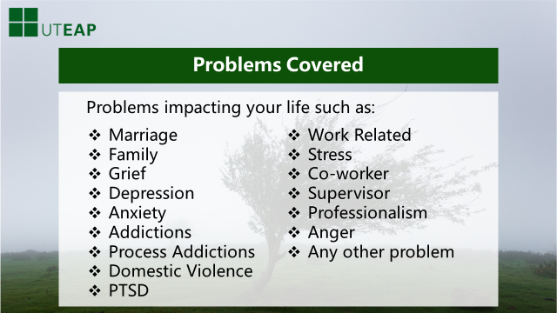
Employees and their family members use UTEAP for a variety of issues, which may include Grief, Eldercare/Childcare, Legal, Financial, Work Related, Process Addictions, Substance Abuse, Anger, Stress Reaction, Depression, Anxiety, Marital & Family Issues.

In other words, the EAP is available for any personal problem that is impacting your life or workplace distress that is impacting on you and your family.

Slide 7
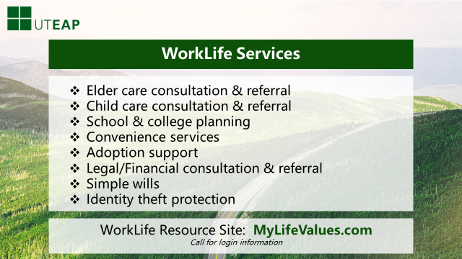
Our program offers a wide range of WorkLife and Wellness services.
Let’s start with Elder Care Consultation & Referral. An employee or family member can call and arrange support services for an elder parent, such as Assisted Living, In home Nurse Care, meals on wheels. Medicare questions are answered and many other services are offered.
Need a new Child Care Provider? The EAP will find you one and advise you how to interview a new Center and what to look for in selecting a service for your child. We will even check for vacancies for you.
Help is offered along with information and resources on educational planning, ranging from pre-school to college. Scholarship opportunities, what to look for in a school and many other services are provided.
Legal Consultation and Simple Wills are included in UTEAP services. Should you need an attorney to assist you, you will receive a 25% discount off normal fees charged.
Financial Consultation is available through UTEAP. Having financial problems? Want to consolidate debt? Need help with a budget? We can assist you. UTEAP can also answer questions on tax preparation, home refinancing and other financial issues.
Identity Theft Prevention is something we are all concerned about. We offer a proactive approach to protecting your identity as well as assistance in recovering your identity should it be stolen.

Just give us a call to talk with one of our expert Work Life service providers and also remember that there is a great deal of information on all of these topics on www.mylifevalues.com.

Slide 8
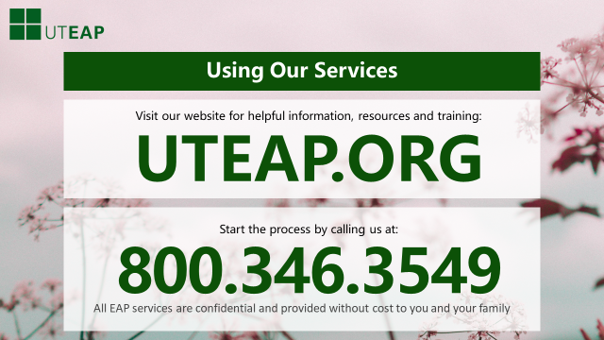
Now you know a little more about the wide range of services UTEAP offers you and your family.
We encourage you to call anytime you are experiencing difficulties and take advantage of your EAP service.

Remember:
- Our Services are Confidential
- There is NO Charge to use the EAP
- We realize you many have more than one issue each year and you are eligible for services and visits with a counselor for each different problem
- Visit our Web site for training and information on a variety of topics as well as Wellness and Work Life services.

Thank you very much and please call us at 1-800-346-3549,
or visit us at www.uteap.org, to make an appointment.

