APPENDIX FOUR

CAMPUS MAP

Harris County Psychiatric Hospital (HCPC) - Lobby Area
2800 S. MacGregor Way (surface parking available across from HCPC)
Houston, TX 77030

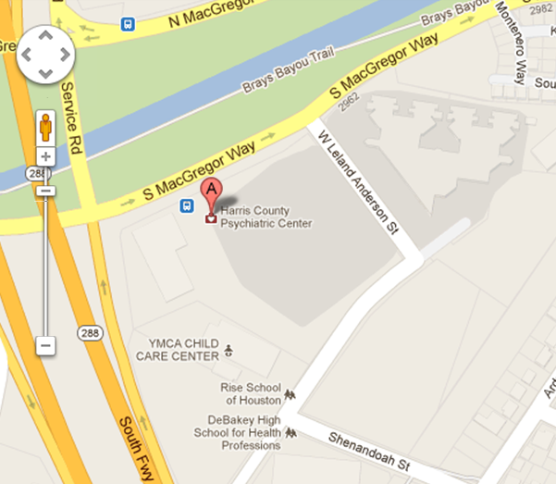
Pay Parking Lot
HCPC

