Appendix 4

CAMPUS MAP

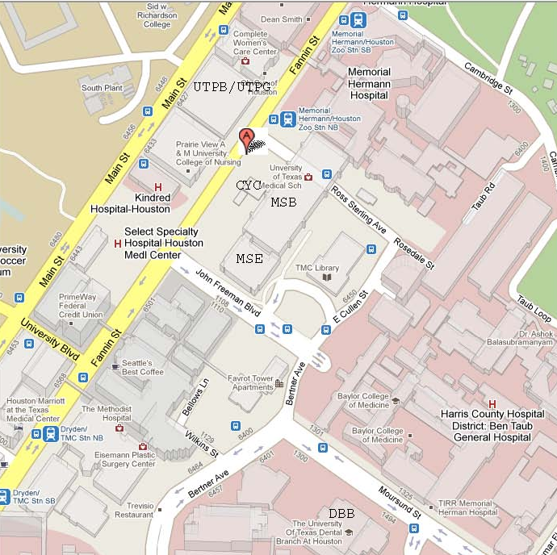
PVAMU

Facility locations in this image:
UTPB/ UTPG - UT Professional Building/ UT Professional Parking Garage
PVAMU – Prairie View A & M Building

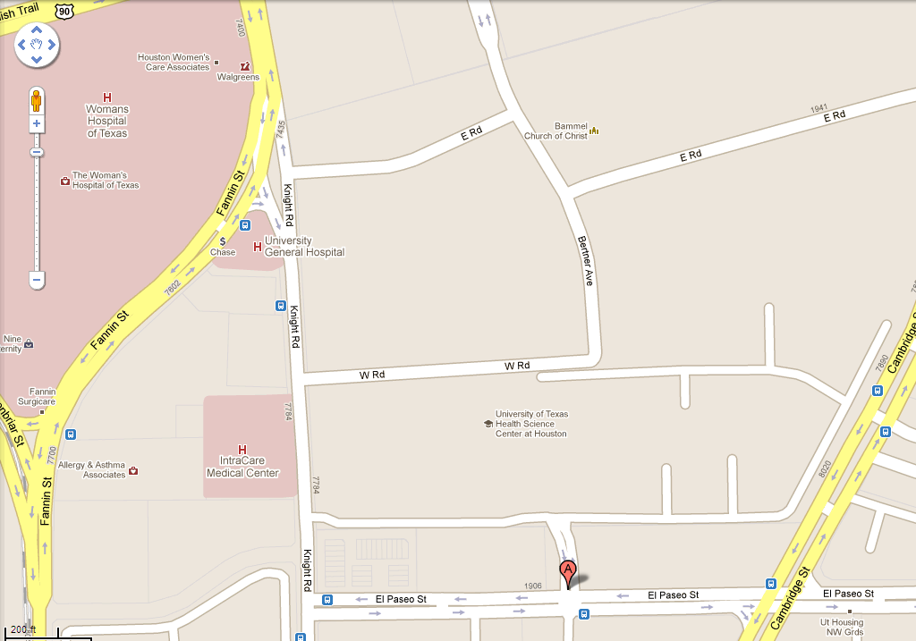

Facility locations in this image:
The University of Texas Health Science Center at Houston
University Housing Complex

