APPENDIX FOUR

CAMPUS MAP

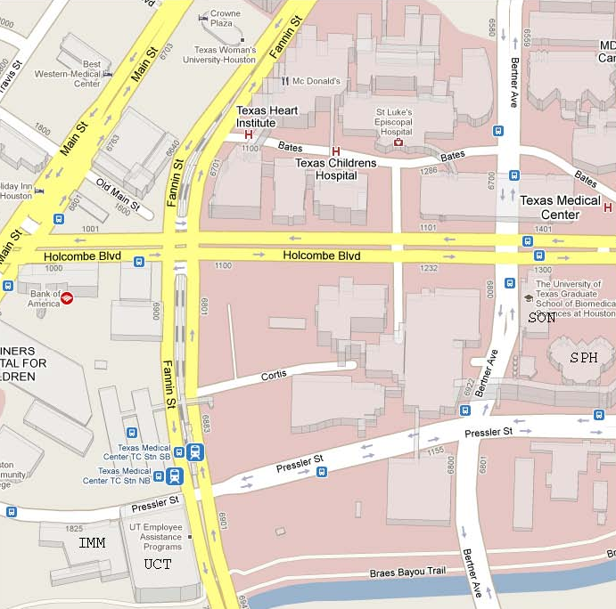

Facility locations in this image:
SON – School of Nursing
SPH – School of Public Health
UCT – University Center Tower
IMM – Institute of Molecular Imaging

