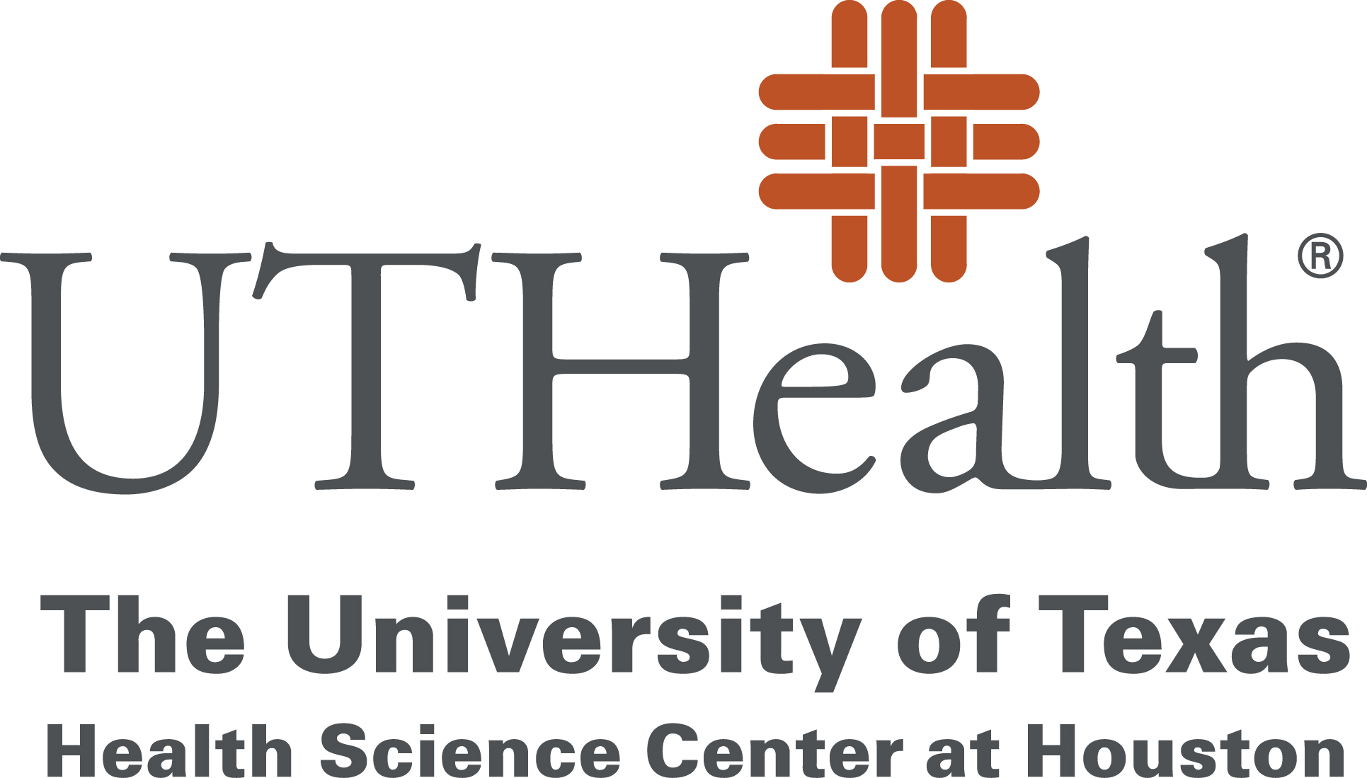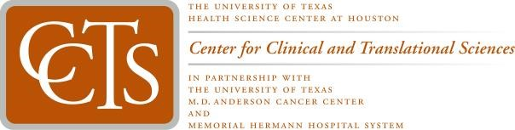

To: | UTHealth Research Community
From: | David D. McPherson MD  Center for Clinical and Translational Sciences
Date Sent: | Monday, March 24, 2020
Subject: | CCTS Update – Clincial Research during COVID-19 Pandemic

In the spirit of supporting research at our institutions during the CoVID-19 pandemic, in line with NIH directives and FDA guidance, the Center for Clinical and Translational Sciences (CCTS) will continue to support ongoing clinical trials. Ensuring the safety and well-being of clinical trial participants is our primary objective. The Clinical Research Unit (CRU) continues to be operational.

The CRU staff will help researchers find ways to ensure compliance with existing protocols, including substituting in-person visits with virtual, phone, telemedicine visits, and mail delivery of investigational products to participants.

In accordance with UTHealth guidelines, we are pausing the accrual of new subjects for general clinical trials. Please visit the IRB page for more information.

CCTS resources are available to help fast track the planning and execution of certain critical clinical trials and trials on CoVID-19. For assistance with the design and implementation of such trials, please contact the Clinical Trials Resource Center (Sujatha Sridhar: 713-500-3622; clinicaltrials@uth.tmc.edu) and the Memorial Hermann Clinical Research Center (Kathy Franco: 713-704-4147; Kathy.D.Franco@uth.tmc.edu).

